Kubernate Deployment Rollback and Rollout:

- Created a project folder and created a deployment.yaml file.
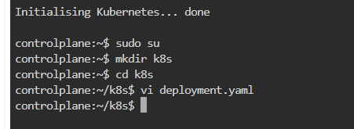
- Created a separate namespace for the fitness application.
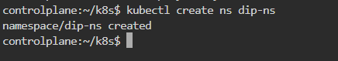
- Edited deployment.yaml and configured ipl app version v1 with required replicas.
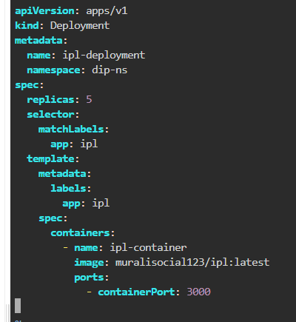
- Apply and run deployment.yaml file and Check if pods created using get all
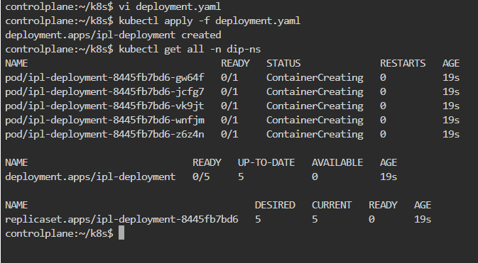
- Describe the pod
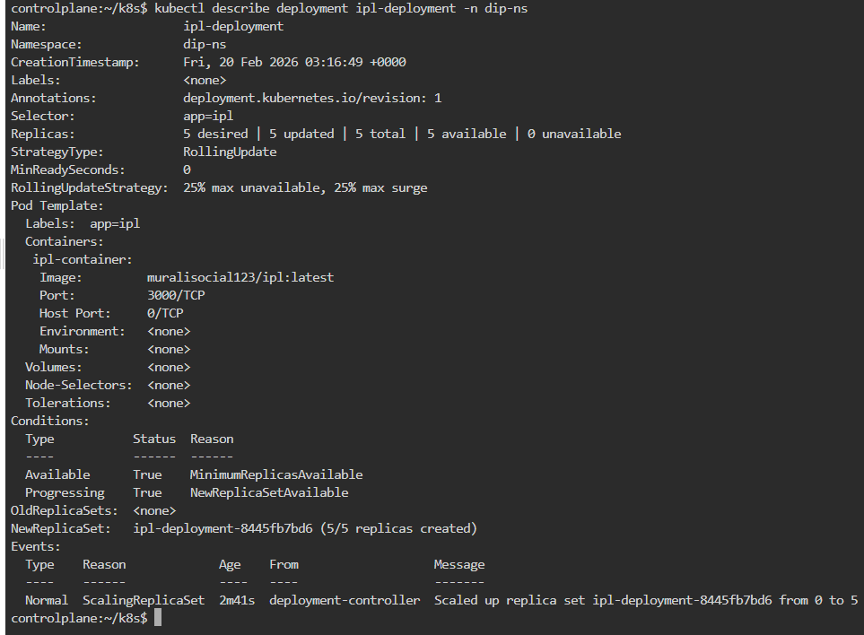
- Image changed
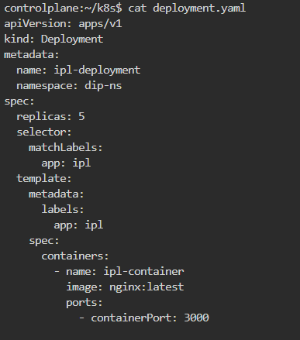
Step 6: check the pods , replicaset and deployments as new pod are created old get deleted new replicaset is also created

Step 7: Here in description we can check pod is of newer version

Step 8: We have used rollback command

Step 9: After rollback newer replicas pod get deleted and old replicas pods get generated also number in front of replicaset is changed

Step 10: Here in description we can check pod is of older version i.e v3

Step 11 : Here we can see status that rolled out is successful

